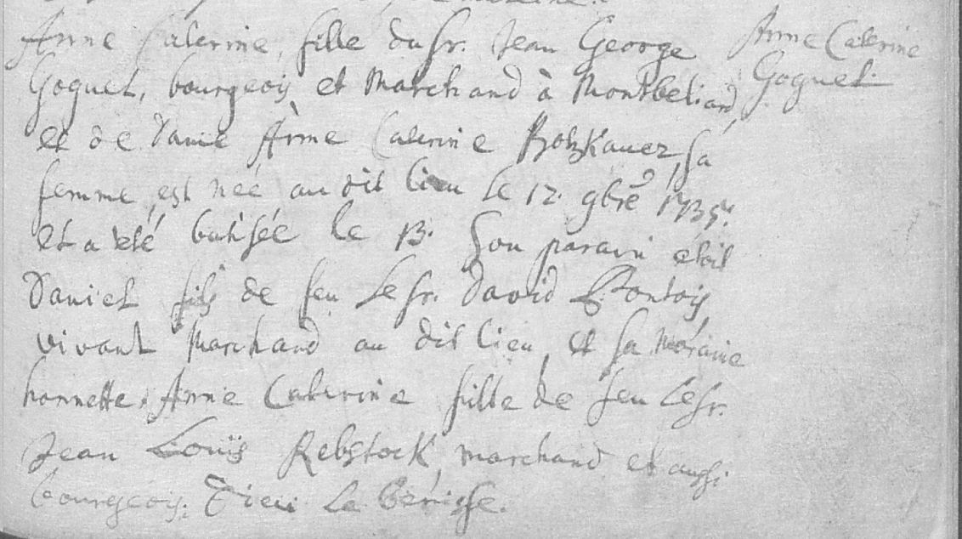
Document from Billie Francile Vardiman’s friends, Alain and Francoise Mathieu from France. Translated from Michelle Diane Vardiman Fansler’s friend who lives in France and speaks English on 8 Feb 2017.

“Anne Catherine, daughter of Professor Jean George Goguel, upper middle class and trader in Montbeliard, and Lady Anne Catherine Potzkauer, his wife, was born in the same place on 12 Feb 1735 and was baptized on the 13th. Her godfather Eloil Daniel, son of Lieutenant David Fontoy, living as a trader in the same place, and her honest godmother, Anne Catherine, daughter of Jean Louis Rebstock, trader and ?”

