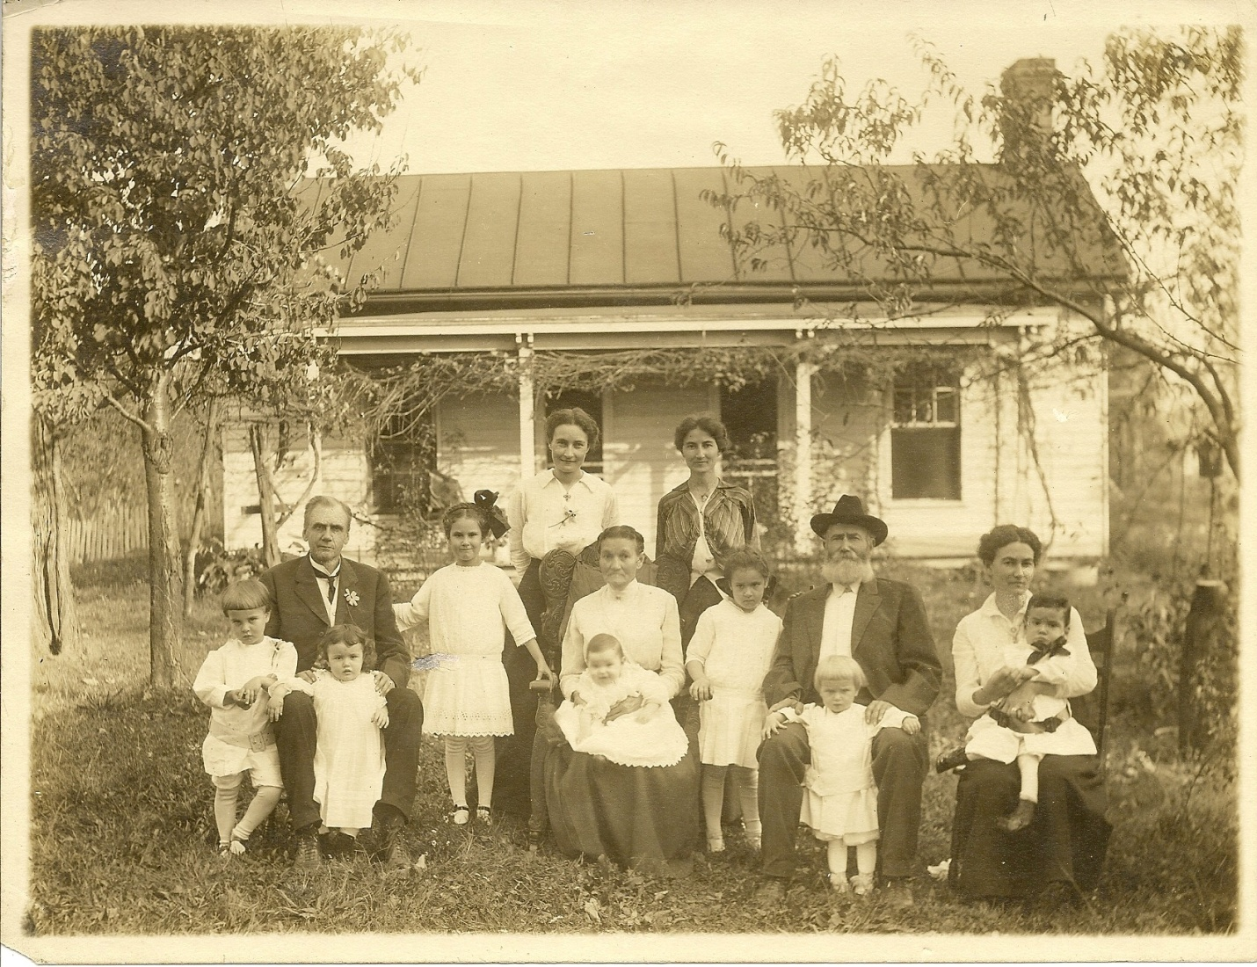

Assessment of above photo by Tracy Hale:
Everyone is wearing their Sunday best but notice the men are still wearing work boots. They have on starched collars. The two women standing in the back are wearing multiple layers of blouses which gives a look called Edwardian Puff and they each have on a Victorian walking skirt. They may be wearing modified corsets. The oldest girl standing is wearing a large bow which was common in 1912-1914 and the children are wearing dresses which were common for both girls and boys at the time.

Notice the older generation is not smiling. They are used to the early form of photography where they had to sit still for a long time and children even had stands to help them hold still.
This photograph was taken in front of their home instead of a studio and the ladies in the back and the children are smiling and are not blurry so photography has advanced at this time with a faster shutter speed. Could have been taken by a traveling photographer.

Best guess: spring 1914, Just before WWI
If you look at a Sears and Roebuck 1913-1914 you will see very similar clothing styles.

