Obituary 20 Jan 2019

Rev. Boyce Arnold Vardiman, age 86, of Waco, died Wednesday.
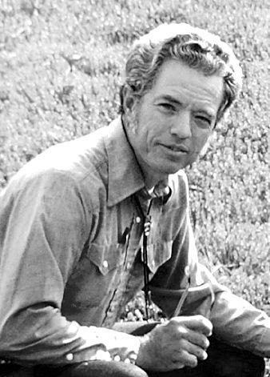
Rev. Boyce Arnold Vardiman
September 1, 1932 -
January 16, 2019

Boyce Arnold Vardiman, 86, of Waco and West, TX, died in Bryan, TX. A Celebration of Life will be held at 1:00 PM on Saturday, February 9 at Lake Shore Baptist Church in Waco. In lieu of flowers, donations in Boyce’s memory may go to Caritas of Waco at 300 S. 15th Street, Waco, TX 76701, or any worthy cause. Arrangements are being handled by Callaway Jones Funeral Home in Bryan, TX.
Boyce was preceded in death by his parents Boyce Taylor Vardiman and Scottie Marie Arnold Vardiman, daughter Deborah Ann Vardiman and granddaughter Taylor Carolyn Mosley. He married Jane Carolyn Jones of Belton in 1954.
After graduating from Killeen High School, Boyce attended Texas A&M, and graduated from Southwestern University in Georgetown in 1953 with a Bachelor of Arts in Sociology. He then received a degree in divinity from Perkins Seminary at Southern Methodist University.
Boyce served for 3 years in the US Air Force as a Chaplain at Lowry Air Force Base, Denver CO. After returning to Texas he served multiple churches in Central Texas and Dallas. His final church assignment was in West, TX where he retired from the United Methodist Church in 1985 after 28 years of ministry.
Always very capable in many ways, Boyce built and remodeled scores of homes in West and the surrounding area as Har-Vard Construction, Inc., with wife Jane as the business manager. He worked hard with many families to achieve their dream of home ownership by financing mortgages they could not otherwise obtain. Boyce and Jane also owned, developed, and managed the Waco/West KOA Campground north of West in 1972-1977. As a small plane enthusiast with an instrument rating pilot’s license, Boyce was a member and leader of Chapter 59 of the Experimental Aircraft Association (EAA); led the construction of the Chapter’s outstanding hangar, meeting facilities, and aviation museum in McGregor; and volunteered with Young Eagles, a program designed to give children ages 8 to 17 an opportunity to experience flight in a general aviation airplane while educating them about aviation.
Boyce had a passion for justice and environmental causes and spoke out and worked for racial equality and economic opportunity for all. He was a longtime member of the West Kiwanis and Waco Friends of Peace. He enjoyed fishing, hiking and camping, and tinkering with cars, carpentry projects, and gardening.
Boyce is survived by his wife Jane of Waco, daughter Rebecca Vardiman and her husband Nelson Cleavenger of Cumberland, MD, daughter Harriet Smith and her husband Philip Smith of Bryan, brother Dr. John Vardiman of Beaumont, sister Scottie Isham of West, grandson Dean Kusler, granddaughters Valerie Martin and Rebecca Mosley, nieces Anne Harris, Carmen Burghardt, and Rose Billingsley, and nephew Dr. Arnold Vardiman.

