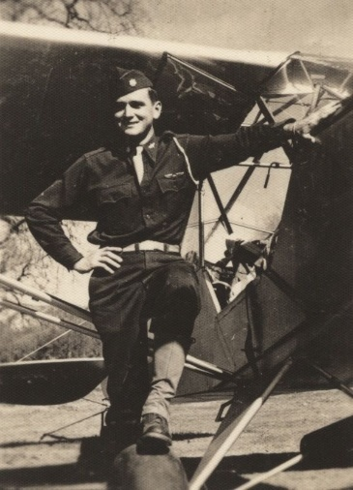
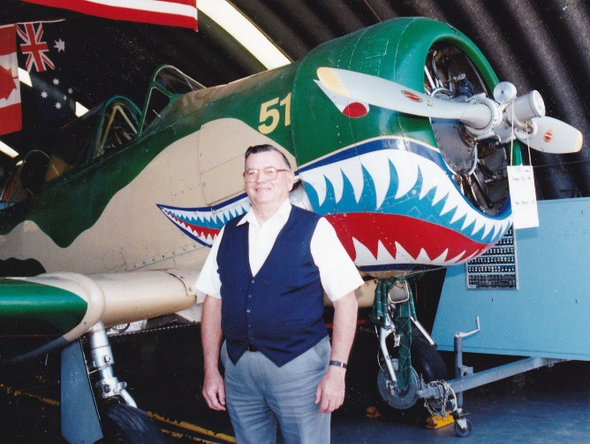

The Bomber Pilot
by Larry Vardiman, 10 May 2018
My uncle, Frank Carter, was a bomber pilot during the Second World War, but you'd have never known it to talk with him. Like so many veterans from the European and Pacific theaters of WWII, he didn't talk about what he'd seen and done -- it was too horrible to recall. I remember as a child asking him what it was like flying a bomber. He simply refused to talk about it.
It wasn't until many years later when he and his daughter, Carol, came to visit my family in San Diego, that he began to open up a bit about his role during the War. Near my home in Santee, California was an airfield that had been used as a base for training paratroopers to invade France and Germany to turn the tide on Hitler's occupation of Europe. Every summer while living in Santee, vintage bomber and fighter aircraft were brought to Gillespie Field for static and aerial displays. For about $300 you could ride in a restored B-17 or B-24 for a short flight. And, for several days each summer I got to watch and hear four-engine bombers landing and taking off less than a mile from my house.
A local detachment of the Confederate Air Force was also located at Gillespie Field. They maintained and flew old aircraft and helped organize the annual "Fly-ins." Their annual air show happened to be scheduled during one of my uncle's visits, so I asked him if he'd like to attend. He said no, which was the response I had expected based on his previous antipathy toward things military. However, when I mentioned to him that the local Confederate Air Force group was having a small open house displaying five aircraft they had restored and the veteran airmen who had flown the planes would be available to talk about their experiences during the war, he indicated some interest. I anticipated that he would back out of going to the open house, but to my surprise, he still wanted to attend after we had breakfast on Saturday.
What happened during his visit to the small hanger at Gillespie Field shocked and thrilled me. I feel privileged to have played a small part in opening up a piece of his life that had been completely shut for over fifty years. When we arrived at the hanger, he found four different aircraft on display, including a B-24 and a B-26 Marauder that he had piloted during bombing missions over Europe and North Africa. The B-26, was one of the most difficult and dangerous bombers to fly. He had crash landed at least two bombers, during which most of the crews on those flights had been killed. Between feeling responsible for the deaths of his crew members and being surrounded by the deaths of so many friends in other aircraft mishaps, it's no wonder he didn't talk about the war.
My uncle had also flown smaller aircraft for a few years with the newly separated branch of the Army, called the U.S. Air Force, when he returned to the States near the end of the War. At the Confederate Air Force hanger in Santee, he got to sit in the pilot's seat of one of the smaller planes he had flown after returning from his rotation to North Africa. For at least a year he had been assigned to fly a spotter plane along the West Coast of the United States locating incendiary balloons launched by the Japanese to set fire to forests and fields from California to Washington. The picture of my uncle shown with this article was with one of those planes.
The pilots at the open house were my uncle's age and had flown similar missions in the same types of planes as he had. Talking with those men that day, surrounded with several of the same planes he had flown, opened a window in his soul that allowed him to reconnect to events and people in his earlier life. He began to talk a bit about what he had witnessed and experienced.
More importantly, my uncle reconnected with many of his former crewmen when he returned home to Louisiana. He located as many of them as he could, who hadn't already died, and began organizing annual get-togethers to remember his old buddies, and rehearse war stories.
My uncle was a Christian and had ministered to many students at Hannibal-LaGrange College in Hannibal, Missouri and at Reece State College in Louisiana for many years before he retired. I think this was one final opportunity for him to minister to others he had known earlier in his life by bringing healing and closure to crewmen damaged by the horrors of war. But, it didn't happen easily for him. It took years for him to come to terms with his trauma caused by the deaths and injuries he saw close up and personal.
The most poignant statement I heard my uncle say about the series of reunions, was a comment he received from one of his crewman when asked, "Why didn't you guys start having these get-togethers sooner?" The crewman said, "We were waiting for you. You were in charge."

