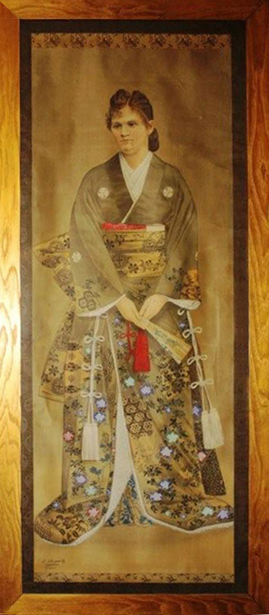
Anna Ewing Cockrell Coromilas
By Sandra Hart, 2010 (her GGreat Niece)
Painting owned by Annie Wilcox, Anna’s Gr Granddaughter
While I am not closely related to Anna Ewing Cockrell Coromilas, her life has fascinated me. She was born on May 26, 1884 in Warrensburg in Johnson Co, Missouri, the youngest daughter of Gen. Francis Marion Cockrell and his third (and last) wife, Anna Ewing. FM Cockrell was a brother of my Gr Gr Grandmother Nancy Cockrell Logan. He was born in Warrensburg, Johnson Co, MO on Oct 1, 1834, an area that was still very much the frontier. He studied law, was admitted to the bar when only 21 and practiced law in Warrensburg until the Civil War began. As a slave owner and ardent supporter of the southern cause, he joined the Confederate army and rapidly advanced through the ranks from private (before the war), to captain (in the Missouri State Guard) and then Brigadier General (in the Atlanta Campaign). Dreadful things happened to his friends and family during the war and he was wounded and imprisoned himself. However, after the war, he put the experience behind him and was pardoned; he was one of the few Confederate Officer to be so recognized with praise by veteran Union soldiers.

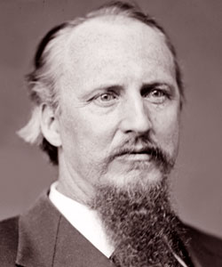
He returned to his law practice until the repeal of the “test oaths” in 1870 allowed him to enter politics. In 1874, he ran (unsuccessfully) as the Democratic nominee for Governor of Missouri. When Charles H. Hardin won, Gen Cockrell jumped on the platform and said, "No man will more loyally support the choice of this convention than I. No man will throw his hat higher for Charley Hardin than will I." and tossed his hat to the ceiling. This generous act won for him a place as United States Senator in the following spring, a position he held for the next 30 years, known for his corncob pipe and linen duster. Defeated in his 6th bid for the Senate in 1905, President Theodore Roosevelt (a Republican) appointed him to the Interstate Commerce Commission. In 1910, President Roosevelt asked him to resign from this position to negotiate a settlement between Texas and Mexico. Senator Cockrell died in 1915 in Washington, DC but was brought home to Warrensburg for burial. He was said to have been an exceptionally intelligent and cultured man, yet acted in a plain and simple manner. He was well respected and loved because he was always gentle and kind.

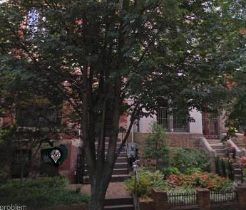
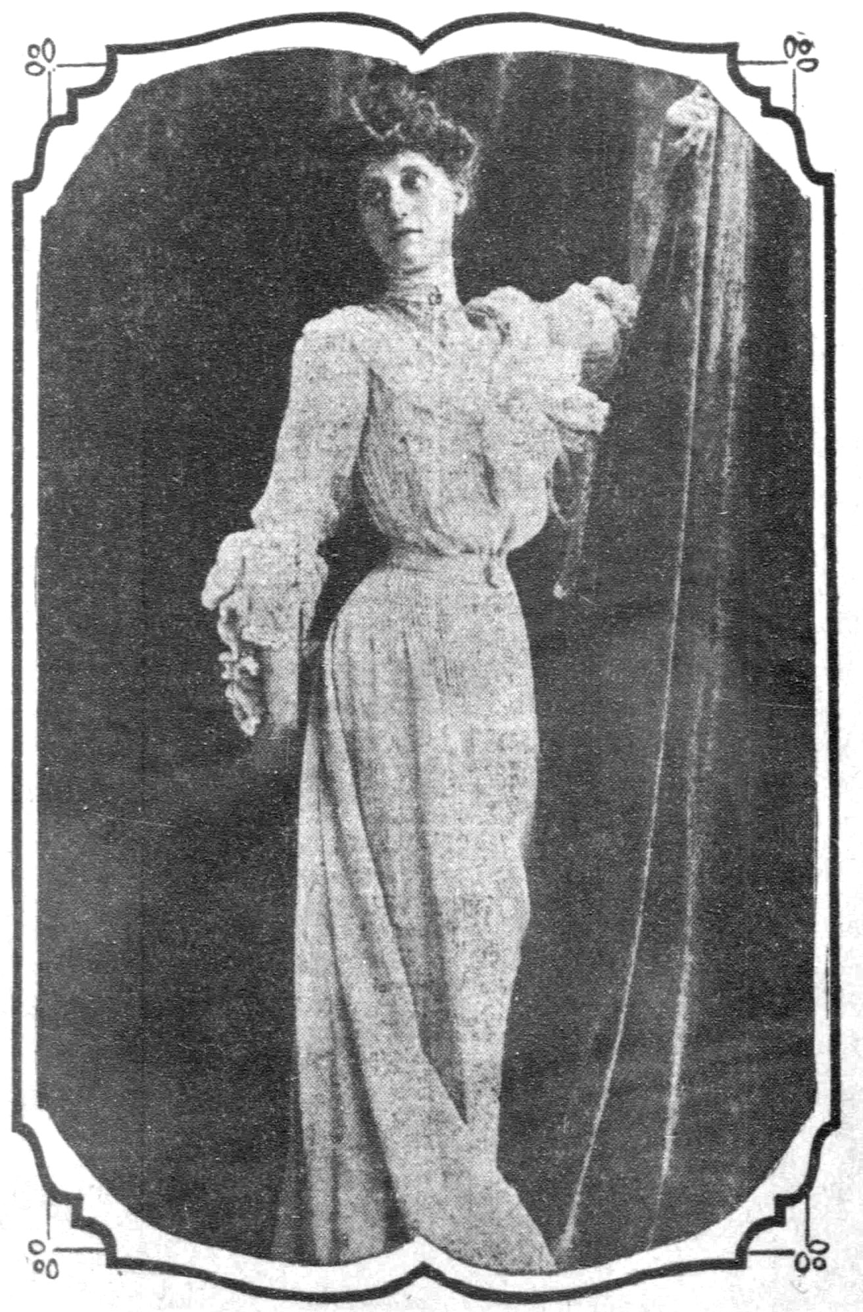
Anna Ewing was named after her mother, who was an unusually brilliant and accomplished woman. She bore and raised seven children of her own, accompanied her husband back and forth to Washington, served as a charter member of the DAR (in 1879) and as the first State Regent of Missouri. Anna Ewing Cockrell had 5 brothers (Ewing, Francis Marion, Ephraim Brevard and Allen Vardeman) and one sister, Marion. After her mother’s death in 1894 when she was only 10, she was placed in the Convent of the Assumption where she remained until she was old enough to join her father in Washington and be presented to society. I wonder if she wasn’t something of a handful, because her other siblings remained in Washington with their father? She made her debut and was featured in a the society columns of numerous newspapers including the New York Times, Washington Herald, and Washington Post. Anna who was described as a “very pretty blond” and the “girl with the perfect profile”, was “stately in appearance with large blue eyes and chestnut-colored hair”. She was well educated, speaking French, German, Italian and Greek and “emerged from a schoolgirl to an official hostess almost in the twinkling of an eye”. In the absence of any other woman in the household, she at once assumed the duties of a Senatorial hostess, which she “discharged with grace, tact, and success”.

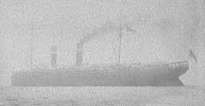
One article reported that she was the guest of honor at a party given by Marion Gallaudet, sister of her future brother-in-law Edson Gallaudet. Another, reported on her sister’s wedding in the church of the Covenant, a “brilliant affair “attended by President Roosevelt, most of the Cabinet and Senate, and the diplomatic community. In 1904, the Washington Post reported that her sister, brother-in-law, and young son were vacationed with his father (Dr. Edward Gallaudet) and in New Hampshire while Anna continued her visit with Mr. And Mrs. Thomas F. Walsh in Colorado Springs, CO.

After 2 seasons acting as the official hostess for her father, she sailed to Europe to spend the winter and spring in Paris. Instead, she stayed for nearly a year, sailing from Cherbourg to New York on the St Louis (see the photo), arriving on Nov 5, 1905. She returned to her father’s home on R St in Washington and to her role as his hostess. She was part of a small social circle centered on the President’s unconventional eldest daughter, Mrs Alice Roosevelt Longworth. It was interesting how society began to mention the use of automobiles of the early 1900s. For example, in 1908 Anna and her father attended a dinner at Cabin John Bridge in honor of Miss Juliette Williams & Joseph Leiter - - the article said they went to the dinner by motor car and took a long ride after.
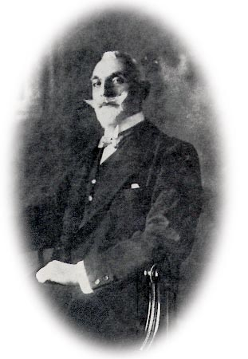
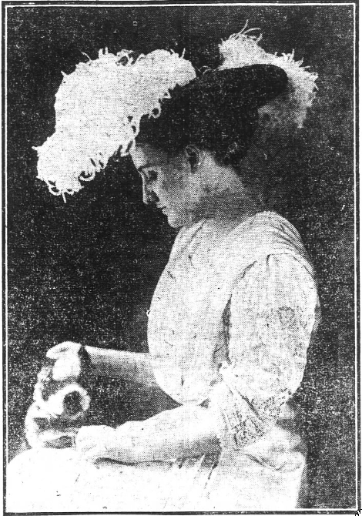
On July 6, 1910, a romance that had been followed with interest in social, political, and diplomatic circles culminated when the Hon Lambros Coromilas, Greek Ambassador to the United States and Anna Ewing Cockrell were married in the drawing room of her sister’s summer home in New London, CN. The Rev Mr Alexopoulos of Washington officiated and her father gave her away. She had no attendants.
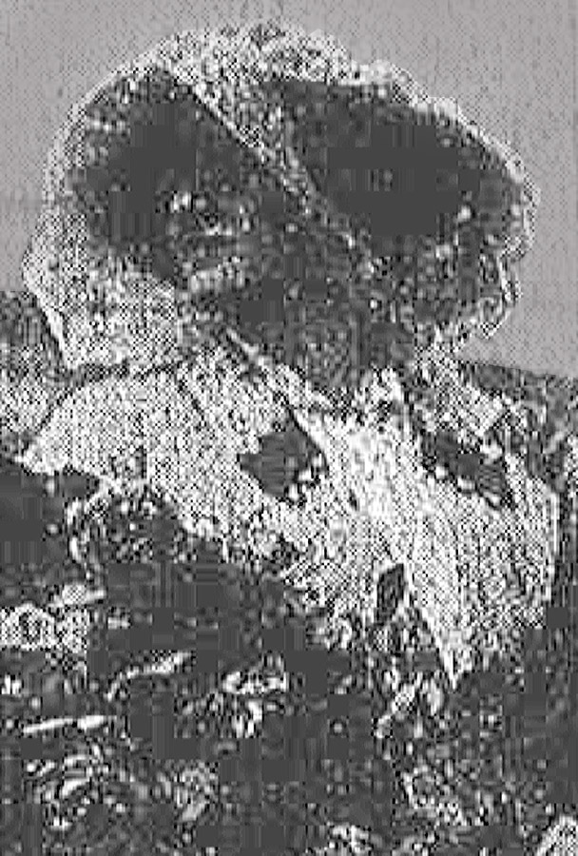
Their brief engagement and simple wedding took place at the “urgent request of Coromilas, who refused to return to his new post in the Cabinet of King Constantine without his beautiful, young American bride”. Although much older than she, he was “one of the most popular and picturesque bachelors of the diplomatic corps”. The small wedding was also in deference to the recent death of the groom’s mother. The decorations included a mass of lilies, ferns, Dorothy Perkins roses, and palms. Anna wore a gown of white chiffon over soft white satin with a high draped girdle embroidered in seed pearls. Her tulle veil was held by strands of seed pearls and orange blossoms. To honor her father, and in deference to the interest in their marriage by official and diplomatic circles, members of Congress contributed to a lovely gift of silver for the newlyweds as they had for Alice Roosevelt when she married. They left the ceremony by automobile on a short honeymoon (a picture of her on her honeymoon is on the left) and embarked for the voyage to Europe from New York four days later, visiting London, Paris, and Constantinople of their way to Athens, where Lambros was to assume a position in the cabinet.

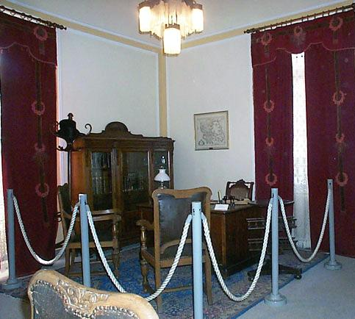
Lambros A Coromilas was born in Athens, Greece in 1857; he was 54, she was 26 when they married. He was educated at the University of Tubigen in Wurtenburg, Germany and L’Ecole Libre de Sciences Politiques in Paris and then traveled around Europe to study financial and economic systems. In 1880, he established a publishing house and began to publish new poetry and literature in the Coromilas Journal. However, he was drawn into public service and was appointed Consul General to Thessaloniki. The energetic new consul built up a network of agents who collected information on enemies of Greece, identified Greek partisans who supported the Macedonian struggle, and controlled covert activities. He was so successful that the Ottoman government asked for his recall. However, the eventual union between Greece and Macedonia saved Macedonia from falling in the hands of the Slavs during the Balkan Wars (1912-13) The street where his Consulate was located was named after him and his office (above) was recreated in a museum near where he served.

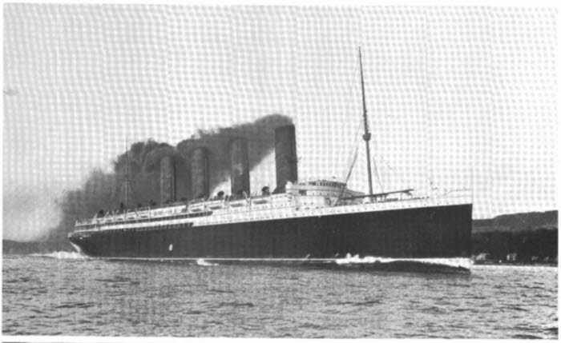
In 1907, Lambros sailed to America on the SS Lusitania (see a picture of the ship and passenger list) to assume his post as the first Greek Minister to the United States in the Greek legation at 2009 Columbia. He made his first appearance in Washington society at the White House New Year’s reception on January 1, 1908.

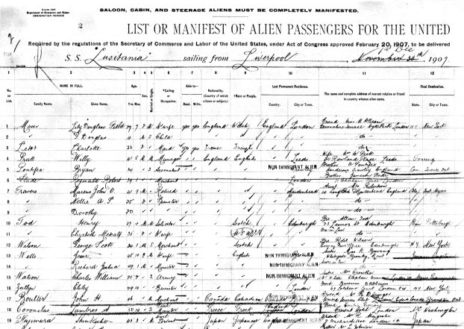
After their marriage, Coromilas rose from the position of Under Secretary of Foreign Affairs, to Minister of Finance in the newly formed Venizelos Cabinet. The success of the Venizelos administration was attributed to his able management of the country’s finances and economic resources.

Apparently Anna’s skill at entertaining also contributed greatly to his rapid rise; an article written about her in 1915 said that relatives of half of the reigning monarchs in Europe had been guests of Anna and Lambros Coromilas. However, in 1912, the Royalist party fell from power, and Coromilas fell into disfavor due to his friendship with the assassinated King George (who was being severely criticized for investing money in his native land, Denmark). The problems Anna and Lambros encountered were reported by the American Press. When his son, King Constantine assumed the throne in 1913, Lambros was appointed Minister for Foreign Affairs. In this capacity, he signed a secret treaty on with Serbia and was most upset when Greece did not come to Serbia’s aid when it was invaded (I have a translation of an impassioned telegram he sent to the King warning him of the growing danger posed by Bulgaria and the increasing dissention in the country). King Constantine’s sympathy for Germany and Venizelos’ sympathies for the Allies resulted in a schism that lasted until after WW2 and forced Constantine to abdicate in favor of his 2nd son Alexander.

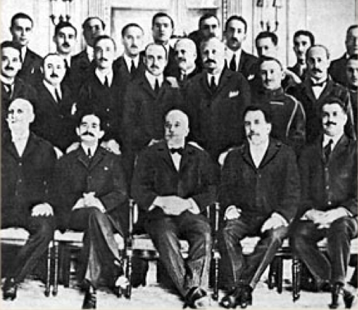
Lambros was sent to Italy as “Minister in Rome”. His position in Italy was most difficult as there were numerous enemies of Greece in Rome due to the tense situation between Albania, Greece, and Italy over the Aegean Islands. However, Anna and Lambros pursued their mission in an “unobtrusive manner and managed to keep on good terms with almost everyone”. The same article reported that during the Balkan War, Mrs Coromilas had sold her marble and alabaster bath from an ancient Greek palace, to raise funds for the Red Cross and that she had also served as a hospital nurse. As the war ended, he and the Greek Prime Minister, Venizelos were received by President Wilson to present arguments in support of Hellenic claims in the war settlement. Coromilas also represented Greece in the formation of the League of Nations (the photo shows the Greek delegation to the League of Nations).

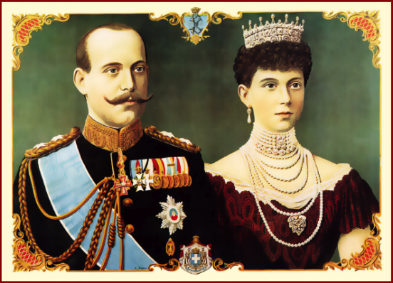
After King Alexander’s death and Venizelios’ defeat in 1920, King Constantine again assumed the Greek throne, but was forced to abandon it a second time in 1922 when Greece lost the Greco-Turkish War. He was succeeded by his son George. King Constantine and Queen Sophia lived in exile in Palermo in the Villa Igiea, supported by money brought to them by Constantine’s brother, Christopher. Coromilas had remained a Royalist, and continued to try to restore the Greek monarchy while “exiled” in Rome. When Constantine, was restored to the throne he appointed Coromilas to his old post as Ambassador to the United States. An article written about them in 1922, on the eve of their return to America, said that “this international marriage had been a most happy one, with the young American wife a great favorite with her husband’s family and a great success in the society of one of the oldest capitals with which America maintains diplomatic relations.” However, Coromilas died before assuming his new post.
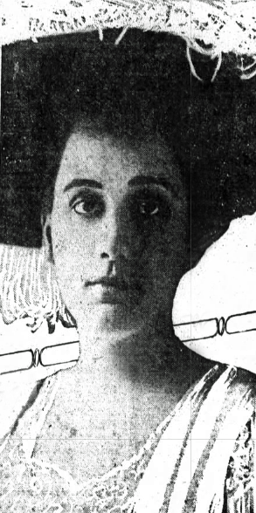
In 1922, a new Greek government executed by firing squad all but one of the Cabinet Ministers who had served under the previous government. These men were blamed for the military disaster in Asia Minor and “knowingly concealing the danger involved in King Constantine’s return to the throne”. According to the newspaper report, the six Cabinet Ministers went courageously, even jauntily, to their deaths, monocles in place”. Prince Andrew, brother of exiled King Constantine and senior Greek generals were arrested and the new King, William, was said to be in jeopardy. The executions caused a shock in diplomatic circles; the Vatican protested, England broke off diplomatic relations, and Mussolini who had tried to stop the executions, refused to recognize the new government. Funeral services held for them in Rome were attended by former King Constantine. Mme Coromilas, now a widow, wrote a letter to the Greek government through the Greek Ambassador to Italy, offering sanctuary to the widows and children of the executed council members, two of whom (Premier Stratos and Gen Hadjanestis) had been her husband’s nephews.

Not long after the death of her husband, Anna Ewing Cockrell Coromilas, fell in love with the Marchese Camillo Casati, Stampa di Sonciono, Marcese di Roma (1877-1946). In 1900, he had married Luisa Amman, the teenage daughter of Count Alberto Amman whose death had left her one of the wealthiest women in Italy. Her husband inspired a fascination with the mystical and macabre and she became increasingly extravagant and scandalous. The New Yorker described her as “tall and cadaverous, with a little feral face swamped by incandescent eyes… She blackened her eyes with kohl, powdered her skin a fungal white, and dyed her hair to resemble a corona of flames; her mouth was a lurid gash.” A year later, their only child, Cristina was born. At 22, Luisa was seduced by Gabriele D'Annunzio who cultivated her appetite for excess. She was dressed by Fortuny and Erte and her her social circle included Salvador Dali, Nijinsky, Isadora Duncan, Ezra Pound, Jack Kerouac and Prince Louis Ferdinand d’Orleans. She wore leopard-skin coats, veils, and feathers, and draped herself with snakes. La Casati, as she was known in the international press, became infamous for her evening strolls parading nude beneath her furs leading cheetahs on diamond-studded leashes.

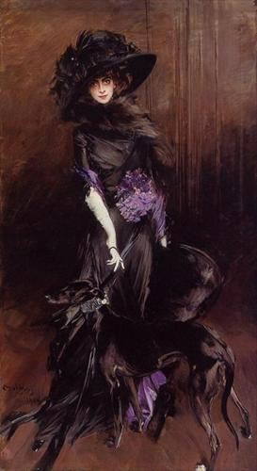
She and her husband began living part not long after their daughter was born. She led a very independent life with unconventional ideas about marriage and motherhood; her decadence and excess inspired The Countess starring Vivian Leigh, A Matter of Time starring Ingrid Bergman, a book by Maurice Druon, La Volupte d’etre, two volumes of poetry by Jean Cocteau and paintings and statues of her by the best artists of the day including a world-famous portrait of her by Man Ray posed in front of the Empress’ rearing white stallions. In 1910, La Casati took up residence at the Palazzo Venier dei Leoni, on the Grand Canal in Venice. Her soirées there would become legendary. Camillo obtained a legal separation from her in 1914, to escape her extravagances and a divorce in 1924 (possibly the first Italian Roman Catholic to do so). Luisa’s return to Paris, the scene previous outrageous escapades was deemed internationally newsworthy, reported in places as unlikely as Fort Wayne, IN.

Shortly after his divorce, the Marchese Camillo Casati moved to Rome, where he began sharing an apartment with the Anna Coromilas. Luisa would neither acknowledge that Anna had replaced her, nor would she allow Anna’s name or that of any of her relatives to be mentioned in her presence. In 1927, the unmarried couple had a son that they named Camillo Casati, after his father. Anna, the Marchese, and their son remained in Italy during Mussolini’s rise to power and World War II.

By the 1930s, La Casati had run through her immense fortune and survived on the generosity of friends. By her 50th birthday, in 1931, she owed as much as $25 million in today’s money. She spent her last years in London. Her daughter with Marchese Casati, Cristina, secretly married Francis John Westerna Plantagenet, the Vicount Hastings, to the dismay of his blue-blood family. Cristina and Hastings left England for the South Sea Island of Moorea where they conceived a child. They returned to England for Cristina’s birth on Mar 4, 1928. They named her in honor of the island they loved and then left her with her paternal grandparents while they went to study art under Diego Rivera in Mexico. Diego Rivera, Freido Kahlo, Cristina, and Hastings formed a long and complex friendship and were vocal supporters of communism. One of Kahlo’s drawings captured the aristocratic hauteur and sophistication of Milan-born, Oxford-educated Lady Cristina. Frida apparently found Hastings’ mood swings between boredom and explosive anger or humor to be congenial and amusing. Cristina was also subject to impulsive rages and remained very political. She and Hastings divorced in the 1940s and she married again in 1944, the Hon Wogan Phillips.

In 1928, Marion Gallaudet, daughter of Anna’s sister Marion and her husband Edson Gallaudet, married Walter Averill Powers, son of the late governor of Maine. They were married in her aunt’s home in the Palazzo Barberini. The wedding was followed by a brilliant reception which was attended by the leaders of the American colony and Italian society.

Anna and Camillo Casati had made their home in the very elegant Palazzo since the 1920s. (see a few photos I took of it in 2011) The Palazzo was originally built for Maffeo Barberini, Pope Urban 8th in 1625. In the early 20th century, it was filled with illustrious tenants to offset Barberini family debts. When Prince Henry Barberini sold the building to the National Gallery in 1949, one of the tenants was still the Marchesa Casati (Anna, I presume). (The newspaper article that reported the marriage of Anna’s niecce also said that Anna was the Marchesa Casati)

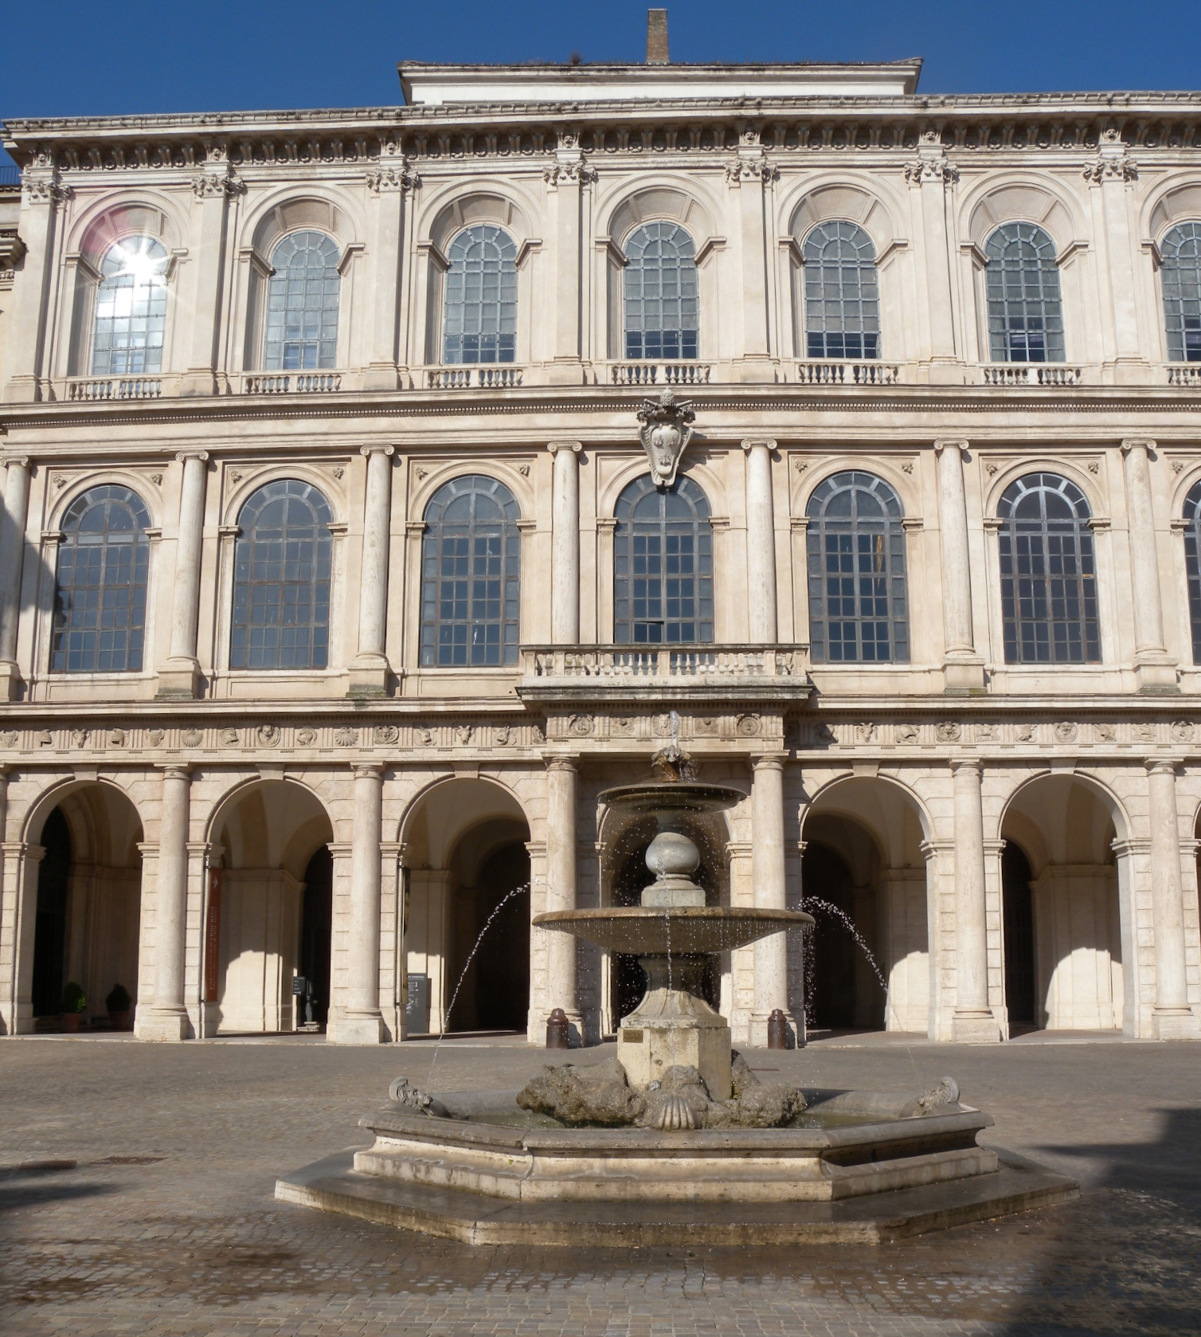
Anna and Camillo remained together for the rest of their lives, although they never married. They lived quietly, surrounded by family, horses, and dogs until his death from cardiac disease on Sep 18, 1946 at the age of 69. Although Anna and Camillo’s son was born out of wedlock, Camillo recognized him as his own and arranged for his son to inherit his title. Sadly, their son committed suicide in 1970 after murdering his wife, Anna Fallarini Casati and her lover. His daughter, Annamaria, born in 1951 to his first wife Lydia Holt (a showgirl), is the last descendant of this line.

Anna had had such an interesting and tumultuous life. She spent her early years in a small town in rural Missouri, was educated in a convent, and then became the belle of the ball in the Capital of the United States, hosting powerful politicians for her father before she was even 20. Then, she married a distinguished, cosmopolitan man many years her senior and lived in the capitals of Europe during the tumultuous years before, during and after WW1. She and her siblings socialized with the families of presidents, congressmen, industrialists, diplomats and European aristocrats. She not only observed the events that took place, but influenced what happened in her role as the hostess of a senior US Senator, wife of an Ambassador, Cabinet Member, and participant in the League of Nations and her own outspoken defense of the deposed Greek monarchy after her husband’s death. It seems that she never returned to America, possibly because of her unconventional lifestyle. The painting of her that I found on the internet, given to her by the Japanese Ambassador, is a fitting last glimpse of her before she retreated into relative obscurity to live what appeared to be a tranquil (albeit affluent) life with her son and the man she loved.

References:
http://anniewilcox.blogspot.com/2010/03/honoring-past-but-looking-forwardwho.html#comment-form (Photo of her in oriental robes, presented by the Japanese Ambassador)
8th census of the US Population, Warrensburg, Johnson, MO, 1860
9th census of the US Population, Warrensburg, Johnson, MO, 1870
10th Census of the US Population, Warrenburg, Johnson, MO, 1880
12th Census of the US Population, Warrenburg, Johnson, MO, 1900
12th Census of the US Population, Washington, DC, 1900
Ship Manifest for the voyage of the Lusitania, Departed Liverpool Dec 1, 1907.
Ancestry.com: New York Passenger Lists (1820-1957)
Ancestry.com: US City Directories
Ancestry.com: US Passport Applications
Athens, Greece: National Historical Museum (Picture of Lambros Coromillas taken between 1904-1907)
Binghamton NY Press, July 16, 1910.
Congressional Directory
Fort Wayne News, Dec 4, 1923, p 17
Judith Thurman, In Fashion, “The Divine Marquise,” The New Yorker, September 22, 2003, p. 172
League of Nations Photo Archive http://www.indiana.edu/~league/councilindivids.htm
Missouri Birth/Death records
New York Times, October 12, 1922
New York Times, November 29, 1922
New York Times, December 1, 1922, p1
Scott D Ryersson & Michael Orlando Yaccarino (Sep, 2004) Infinite Variety, The life and Legend of the Marchesa Casati, Minneapolis: University of Minnesota Press.
Reno Evening Gazette, American Girl Marries in Rome. Mar 28, 1928
Syracuse Post Standard, Jul 6, 1910
The Atlanta Constitution, Oct 12, 1922, p7
Washington Herald, June 26, 1910, Society, p2
Washington Post, Dec 76, 1904, p9
Washington Post, October 30, 1910, p3
Washington Post, Jul 2, 1910, p7
Washington Post, November 8, 1905, Page 7
Washington Post, June 29, 1910, p7
Washington Post, June 22, 1910, p7
Washington Post, May 30, 1908, p7
Washington Post, March 10, 1914, p2
World Peace foundation, A League of Nations, Google Books online.
WW1 State Department Records, International Relations, Serbia & Austria, October, 1918, 763.72/11804, p7

